Scope of Work – Works addressed by this document include the following;

- Site Access
- Environment
- Site Preparation Works.
- Locating and exposing cables either side of Signalling / Communications location cases and cabinets.
- Installation of Galvanised Steel Troughing
- Construction of hand built Besser Block Pits
- Backfilling of Excavations.
- Reinstatement of area / site clean-up.

Note that this SWMS is to be used as the site specific induction for the works. The register at the back of this document is to be maintained at all times.
AUTHORISING JHR PERSON (print) | Rod Rowlands – Senior Engineer  0429 707 847 | SIGNATURE : | DATE :
SUPERVISOR OF THE WORK (print) | Wall y Elford – Supervisor  0458 532 569 | SIGNATURE : | DATE :
OHS REPRESENTATIVE (print) | Sandra Veli – Project Safety Coordinator  0419 694 776 | SIGNATURE : | DATE :
Max. No. of Employees to be used on site | 15 | Expected Start Date | 12.5.10
Min. No. of Employees to be used on site | 2 | Duration of Work | 12.6.10

HAZRDOUS SUBSTANCES TO BE BROUGHT TO SITE
Product Name | MSDS (available) |  |  | MSDS (available)
Product Name | YES | NO |  | YES | NO
Sand / Cement | X |  | 2 Stroke Fuel | X
Galmet Paint | X |  | Marking Paint | X
Diesel Fuel | X
NOTE: MSDS ARE KEPT ON SITE AND COPY OF MSDS ARE LOCATED IN JOHN HOLLAND POSSESSION PACK

 | RISK MATRIX
 | Consequences |  | Likelihood or Probability
 | People | Environment |  | A | B | C | D | E
 | People |  |  | Almost Certain  (expected) | Likely  (will probably occur) | Moderate (might occur - has happened) | Unlikely  (could occur - known to happen) | Rare  (practically impossible) |  | Risk Ranking | Risk Score |  | Risk Description
1 | No Incident or  First Aid Injury | Negligible Discharge |  | High  15 | Medium  19 | Low  22 | Low  24 | Low  25 |  | Low | 21 - 25 |  | Tolerable. Monitor, manage and carryout activity in accordance with identified controls.
2 | Medical Treatment | Uncontrolled Discharges in Minor Quantities |  | High  10 | High  14 | Medium  18 | Low  21 | Low  23 |  | Medium | 17 - 20 |  | Implement strict control measures reduce hazard to ALARP. Activity must not commence without appropriate Supervision.
3 | Alternate Work or Lost Time Injury | Moderate Breach of Environmental Statutes |  | Extreme  6 | High  9 | High  13 | Medium  17 | Medium 20 |  | High | 9 - 16 |  | Implement strict control measures reduce hazard to ALARP. Activity must not commence without Management approval and appropriate Supervision present. Review process.
4 | Serious or Permanent Injury | Major Breach of Environmental Statutes |  | Extreme  3 | Extreme  5 | Extreme  8 | High  12 | High  16 |  | Extreme | 1 - 8 |  | Intolerable. Activity must not commence. Eliminated hazard or introduce further controls to reduce to ALARP.
5 | Fatality | Shutdown of Project due to Environmental Breach |  | Extreme  1 | Extreme  2 | Extreme  4 | Extreme  7 | High  11

PERSONNEL DETAILS |  | EQUIPMENT DETAILS
Occupations  Trades/Skills/Work Teams | Labourer, Protection Officer, Brick layer Electrician, ,  Supervisors | Static Plant and Equipment | Generator, Battery Operated Drill, Hydraulic Crimping Devices, Basic Hand Tools
No. of Employees  (Req’d to do the work safely) | Varied dependant on sequenced activity | Mobile Plant and Equipment | Excavator, Truck
Qualifications  Licenses / Qualifications / Permits | Protection Officer, John Holland Rail Site Specific Induction, WorkCover Construction Induction, RailCorp Issued RISI Card, RailCorp (PWIA) Projects Work Interface Agreement. | Safety/Emergency Equipment | First aid kits, spill kits, fire extinguishers and fire fighting equipment. Rotating beacons and motion alarms on all mobile plant on site. UHF radio communications
Training  Completed and/or required | Superintendent supervising the job is to make sure: John Holland Site induction, WorkCover construction industry induction, RailCorp Issued RISI Card and any necessary competency tickets | Personal Protective Equipment | Mandatory Gloves, Medium Impact Safety glasses, Ankle height, steel cap, laced safety boots, industrial clothing (long sleeves and pants), hearing protection, Approved hi-vis vest (with reflective tape), hardhat, face shield when required, sunscreen. Persons may be directed to use additional PPE by the site safety coordinator/supervisor or by client

 | POTENTIAL  HAZARDS | Hazard Ranking Risk Score | PROPOSED ACTION/ CONTROL MEASURE | Control Ranking & Risk Score | Action By
Break the job down into steps.  Each step should accomplish some major task and be in a logical sequence | Identify the hazards associated with each step.  Examine each to find possibilities that could lead top an accident | Assess the Risk | Specify what action/procedures will be taken to eliminate or minimise the hazards, the risk of injury/damage, and/or potential severity factors. | Reassess the Risk | Who is responsible
1. Site Access | Unathorised personnel including visitors entering construction area (rail corridor) | 8 | All personnel to undergo John Holland Rail Induction, and ensure you are briefed by the worksite protection officer and supervisor.  Inducted personnel must have their induction cards on them at all times to display when asked.  All access gates in the vicinity must be locked or manned at all times and applicable signage and contact details must be displayed. | 20 | Supervisor  Protection Officer
1. Site Access | Competency of personnel on site is not appropriate to the skills required to perform the work correctly and safely | 4 | Personnel to hold current RailCorp issued RISI, and WorkCover Construction Induction certificate. All competencies, licenses and other job specific qualifications to be checked prior to entering the site by the appropriate supervisor. | 20 | Supervisor  Protection Officer
1. Site Access | Personnel consuming or working under the influence of alcohol and or illicit drugs causing injury to personnel, damage to property, struck by train or plant and equipment | 4 | Ensure all personnel are aware of the Southern Sydney Freight Line, John Holland Construction rules and implications at the time of the induction and pre work brief. Reinforce the drug and alcohol requirements on an ongoing basis through “toolbox talks” and “Daily Team Briefings” as Zero Tolerance. Note: Random Testing will be conducted on site. | 20 | Supervisor
2. Environment | Struck by train / rail traffic. | 4 | Attend site briefing with protection officer for the purpose of working in the rail corridor and sign on to the “Work Site Protection Plan and Pre Work Brief”. All personnel to read and understand protection arrangements. Ask questions if unsure. | 17 | All
2. Environment | Injury to personnel from exposure to extreme weather conditions | 13 | Mandatory PPE to be worn along with sun cream, brims under hard hats, UV safety glasses long pants and shirt.  Ensure that rotation of task and regular rest breaks  Ensure that water supply is readily available, and sheltered areas away from the elements. | 25 | All
2. Environment | Injury to personnel, muscular strains (Manual Handling) | 13 | Ensure that correct manual handling techniques are adopted. Ensure that the John Holland Manual Handling HELP poster is briefed, and where possible use mechanical aids, and team lifts. | 25 | All
2. Environment | Fatigue | 13 | Effective rostering and planning  Adhere to 10 hour working rule  Rest breaks of no less than 12 hours prior to commencing work on site  Visual assessments of employees  Report to supervisor if you are feeling fatigued  Accommodation to be provided if required | 25 | All
2. Environment | UV / Skin damage / cancer  Eye damage – cataracts / cancer | 13 | Wear broad brim on helmets.  Use SPF +30 sunscreen.  Wear long sleeved (cotton) shirts & pants.  Safety sun glasses to be worn  Drink plenty of water.  Provide shade & rest breaks during extreme weather. | 25 | All
2. Environment | Snakes, Spider, Bee Stings and Bites | 18 | Mandatory PPE to be worn at all times. Avoid at all times and do not cause aggravation. First Aid kits available  Trained first aider in each crew clearly identified on pre work briefing. Take care to check for any infestations, particularly during excavation and inspection of pits and underground services. | 21 | All
2. Environment | Mobile Phone Usage | 18 | Ensure that phone calls made and received whilst in the corridor are in the designated safe place. Under no circumstances are you to be in the danger zone. | 21 | All
2. Environment | Slips Trips and Falls | 18 | Site specific induction noting the ground conditions and where special attention needs to be made  Ensure all housekeeping is adequate and the correct storage of equipment and rubbish  Ensure ankle height, laced, steel cap safety boots are worn and that there is adequate lighting especially during darkness. | 21 | All
2. Environment | Damage to RailCorp Infrastructure | 13 | Ensure that where plant and equipment is used in close proximity to RailCorp electrical infrastructure / assets that risk controls are used such as (concrete jersey kerbs, water filled barriers. | 21 | All
2. Environment | Ground Disturbance – Damage to underground assets | 13 | Ensure that a Excavation permit is obtained for any activity that disturbs the existing ground material and includes excavation, grading, driving a start picket, and any mechanical or manual digging or any activity that disturbs the existing ground. | 21 | Supervisor
2. Environment | Electrocution from Overhead Wires / Underground Services  Approach distances for work performed by Accredited Persons with a Safety Observer. | 4 | Working in close proximity to overhead powerlines prior to proceeding with works adjacent to the live Overhead Power Lines, John Holland must request relcoation or isolation of the asset owner’s line before construction work proceeds. All overhead lines should be treated as live unless the operator has received access authority or other form of written documentation from the network operator.  The following mimum safe approach distances apply. Ensure that machines that have the possiblity to encroach are fitted with height restrictors, and ensure a spotter observer is in place.  NSW Code of Practice, Work near Overhead Power Lines.  Approach distances for work performed by Ordinary Persons. | 17 | All
  Nominal phase to phase a.c. voltage (volts) | Approach distance (m)
  Insulated low voltage cable up to 1000, including LV ABC | 0.5
  Un-insulated low voltage conductors up to 1000 | 1.0
  Above 1000 up to and including 33,000 | 1.2
  Above 33,000 up to and including 66,000 | 1.4
  Above 66,000 up to and including 132,000 | 1.8
  Above 132,000 up to and including 220,000 | 2.4
  330,000 | 3.7
  500,000 | 4.6
  Above 330,000 | 8.0
  Nominal pole to earth d.c. voltage (volts) | Approach distance (m)
  Up to and including +/- 1500 | 1.0
  Nominal phase to phase a.c. voltage (volts) | Approach distance (m)
  Up to and including 132,000 | 3.0
  Above 132,00 up to and including 330,00 | 6.0
  Above 330,000 | 8.0
  Nominal pole to earth d.c. voltage (volts) | Approach distance (m)
  Up to and including +/- 1500 | 3.0
2. Environment | Injury to personnel due to alternate Production / change in scope of work. | 13 | Stop work assess situation  Confirm with all personnel and sign off toolbox  Review / update SWMS / START card | 21 | Supervisor
2. Environment | Obstruction of live tracks during non possession work | 4 | A demarcation fence not less then 3 metres from the closest running rail and a suitably qualified protection officer to work within the work team and ensure that the level of work site protection is adequate for the task being performed. | 17 | All
2. Environment | Electrocution to personnel from the use of faulty electrical equipment | 4 | Supervisors are to ensure inspections are carried out of all equipment prior to use and ensure that tags for tag testing are in date. Any equipment that is found faulty or damaged must be tagged out with out of service tag and removed from service. All equipment must be tagged and tested on a monthly basis by a licensed electrician. Ensure equipment is properly stored to prevent damage – and residual current devices to be installed on portable generators. | 17 | All
2. Environment | Cuts. Sprains, strains, abrasions, from use of hand tools and equipment | 13 | All tools and equipment must be selected to minimize risk to employees, ensure correct tool for the task. Small tools to be thoroughly inspected prior to use, and ensure all personnel are adequately trained in the correct use of tools. Correct PPE must be worn at all times, and if heavy lifting is involved ensure that correct manual handling techniques are adopted. | 21 | All
3. Site Preparation Works | Site specific / work specific hazards | 18 | Site supervisor to brief workers into SWMS, Excavation permit and prestart work brief. All workers to understand requirements. Ask questions if unsure. | 23 | Supervisor
3. Site Preparation Works | Storage and stockpiling. Dust, run-off, spillage. | 13 | Store materials in clearly marked, designated safe area. Dust, run-off and spillage to be controlled by appropriate means. Eg: barriers, drainage filters / fences, covers. | 17 | All
3. Site Preparation Works | Access to site by machines, plant, delivery trucks.  Access through site, plant, truck, vehicles, Struck by train, Struck by vehicle, Struck by hi rail and other mobile equipment, collision with other construction traffic, plant. | 13 | Ensure that the protection officer has given worksite protection briefing indicating method of protection for work on track, no personnel to enter corridor until briefed. Traffic control plans and signage if required. 10km per hour speed limit within rail corridor to avoid generation of dust. Ensure that spotters are used when any trucks or plant are reversing. When stopping or parking vehicles ensure that it is in an area that can be clearly seen by others. Ensure parking is out of the danger zone. Ensure all access gates are locked or manned at all times. | 17 | Supervisor
3. Site Preparation Works | Loading and unloading equipment materials from vehicles  Lifting and Lowering Loads, equipment, failure, drop of loads, crush injuries | 13 | Correct lifting appliances i.e. hiab to be used at all times and with the correct SWL noted on the equipment. Ensure the rated capacity indicator is on at all times.  Ensure personnel to remain at a safe distance during unloading, stacking unless authorized to assist.  Drivers only to conduct or manage unloading operations and risk assessments must be conducted prior to deliveries being planned to ensure all hazards from overhead services are addressed.  Competencies to operate lifting appliances are required. Dogman required for slinging, calculating loads.  Ensure that all slings, chains are visually inspected for wear and tear, stretch prior to use and are tagged with inspection date. All lifting gear must be registered by John Hollands and a register must be signed by qualified dogman as verification of equipment inspected on a monthly basis. Ensure pre start checks are completed to identify fault, plant/equipment to prevent equipment failure. | 17 | Supervisor
3. Site Preparation Works | Struck, cut, crushed or stabbed by equipment on site | 4 | Exclusion zones to be set up whilst unloading materials and equipment. Supervision and adequate training must be provided  Minimise ground personnel, ensure correct use of PPE and ensure hands are kept clear of any crushing or pinch points. | 17 | Supervisor
4. Locating and exposing cables either side of Signalling / Communication Locations and Cabinets. | Clearing area with plant, machines or by hand. | 13 | When clearing large areas minimise the dust with water spray and always stockpile spoil safely, away from access roads in a well marked, designated area. | 17 | All
 | Fumes and contamination from marking paint. | 13 | Use marking paint in a well ventilated area and use respirator masks and eye protection wherever appropriate, particularly within the confines of pits, enclosed spaces and under buildings and structures. Minimise use of paint in and around obvious water courses and drains. | 17 | All
 | Splashes and eye injuries from particles when using blaster / vacuum potholing systems. | 13 | Always wear the appropriate PPE including eye and face protection, masks and gloves when operating or nearby high pressure water blasting devices ensure exclusion zone is in place to prevent unnecessary personnel from entering the area. | 17 | All
 | Contact with cables / services. | 8 | Proceed with extreme care, by hand if necessary. Excavation to remain within new SSFL civil works formation, Excavation permit to include rail Corp DSS. If contact is made with a service, stop work immediately and assess the risk before continuing to dig. Report and document any new or hidden services revealed during excavation. | 17 | All
5.Installation of Galvanised Steel Framework | Tool cuts and abrasions. | 13 | Take care when using powered cutting tools and make sure safety guards are fitted correctly. Always wear the appropriate PPE including eye protection, gloves and long sleeves. When using hand operated or hydraulic cutting tools and crimping devices, keep hands and fingers well clear and always operate correctly, adhering to manufacturers instructions and manuals. | 21 | All
5.Installation of Galvanised Steel Framework | Chemical contamination from glues, setting resins and compounds | 13 | When using resins and cable sealants, always use the appropriate PPE including gloves, eye protection and face mask / respirator. Dispose of any waste in a safe manner. | 20 | All
5.Installation of Galvanised Steel Framework | Cuts and abrasions from sharp edges. | 8 | Handle any sharp edges with care. Use tools, ropes and chains / slings to avoid direct contact with hands when appropriate. Always wear correct PPE including heavy gloves. | 17 | All
5.Installation of Galvanised Steel Framework | Electrocution from contact with Overhead Wiring | 4 | Always take care when moving GST around the worksite. GST to be carried by 2 persons, one at each end to minimise risk of GST coming into contact with Overhead Wiring | 17 | All
6. Construction of hand Built Besser Block retaining walls | Loading and unloading equipment materials from vehicles  Lifting and Lowering Loads, equipment, failure, drop of loads, crush injuries | 13 | Correct lifting appliances i.e. hiab to be used at all times and with the correct SWL noted on the equipment. Ensure the rated capacity indicator is on at all times.  Ensure personnel to remain at a safe distance during unloading, stacking unless authorized to assist.  Drivers only to conduct or manage unloading operations and risk assessments must be conducted prior to deliveries being planned to ensure all hazards from overhead services are addressed.  Competencies to operate lifting appliances are required. Dogman required for slinging, calculating loads.  Ensure that all slings, chains are visually inspected for wear and tear, stretch prior to use and are tagged with inspection date. All lifting gear must be registered by John Hollands and a register must be signed by qualified dogman as verification of equipment inspected on a monthly basis. Ensure pre start checks are completed to identify fault, plant/equipment to prevent equipment failure. | 17 | Supervisor
6. Construction of hand Built Besser Block retaining walls | Tool cuts and abrasions. | 13 | Take care when using powered cutting tools and make sure safety guards are fitted correctly. Always wear the appropriate PPE including eye protection, gloves and long sleeves. When using hand operated or hydraulic cutting tools and crimping devices, keep hands and fingers well clear and always operate correctly, adhering to manufacturers instructions and manuals. | 21 | All
6. Construction of hand Built Besser Block retaining walls | Cuts. Sprains, strains, abrasions, from use of hand tools and equipment | 13 | All tools and equipment must be selected to minimize risk to employees, ensure correct tool for the task. Small tools to be thoroughly inspected prior to use, and ensure all personnel are adequately trained in the correct use of tools. Correct PPE must be worn at all times, and if heavy lifting is involved ensure that correct manual handling techniques are adopted. | 21 | All
6. Construction of hand Built Besser Block retaining walls | Chemical contamination from glues, setting resins and compounds | 13 | When using resins and cable sealants, always use the appropriate PPE including gloves, eye protection and face mask / respirator. Dispose of any waste in a safe manner. | 20 | All
6. Construction of hand Built Besser Block retaining walls | Concrete mix, soil and dust contamination. | 13 | If disturbing soil, dust and while mixing concrete, use the appropriate PPE including eye protection, gloves and respirator masks as required. Minimise spills and contamination of immediate area. Concrete spills cause environmental hazards and must be cleaned | 17 | All
7. Backfilling of Excavations. | Contact with cables / services. | 8 | Proceed with extreme care, by hand if necessary. If contact is made with a service, stop work immediately and assess the risk before continuing to dig. Report and document any new or hidden services revealed during excavation. | 17 | All
7. Backfilling of Excavations. | Collision with mobile plant and machinery. | 4 | Always take care around moving plant and make eye contact with operators before approaching. Keep a safe distance clear of plant when working nearby (3m exclusion zone if possible). Use spotters in tight confines or where plant is likely to interfere with other personnel. | 20 | Supervisor
7. Backfilling of Excavations. | Collapse or otherwise burying hazards. | 4 | Take care when machinery is used near edge of trenches. Under no circumstances should persons enter trenches while backfilling is in progress. At all times the operator needs to stay aware of all persons in the vicinity of the trench. | 17 | All
8. Reinstatement of area / site clean-up. | Trips, and falls. Vehicle and personnel hazards. | 17 | Make sure area, in particular traffic areas, paths and access roadways are clear of any debris or uneven surfaces after cleanup works. Any areas that are still hazardous should be clearly marked with tape and signage until the cleanup can be fully completed. | 23 | All
8. Reinstatement of area / site clean-up. | Collision (Mobile Plant) | 4 | Personnel to be fully aware of mobile plant operating, and must make contact with operator if wanting to pass into the area. Supervisor is to ensure whilst mobile plant is operating that exclusion zones are in place, and that mobile plant has audible alarm and flashing amber beacon. Safe access walking areas must be identified and made known to personnel on the brief. | 20 | Supervisor
8. Reinstatement of area / site clean-up. | Collision (Plant/Person/Static Objects). | 4 | In addition to the above communication to be maintained between operators and ground level personnel. Objects are not be left lying around where mobile plant can strike. Existing infrastructure must be barricaded to prevent mobile plant from striking. | 20 | Supervisor
8. Reinstatement of area / site clean-up. | Items left lying around – fouling line | 5 | All equipment must be cleared and nothing is to be left lying around that can foul the track or cause house keeping hazards. | 20 | Supervisor
8. Reinstatement of area / site clean-up. | Site Security – Vandalism, unauthorized access | 5 | Access Gates are to be securely locked, all equipment accessed (infrastructure) must be locked. Supervisor must double check site prior to leaving to ensure that this has been done. | 20 | Supervisor
8. Reinstatement of area / site clean-up. | Contamination from stockpiles, scrap and other redundant materials. | 13 | If materials are stockpiled or stored, provision must be made to avoid contamination of water-ways, drains and the surrounding environment. Catch filter screen fencing to be used where a potential for contamination exists during rain. | 17 | Supervisor

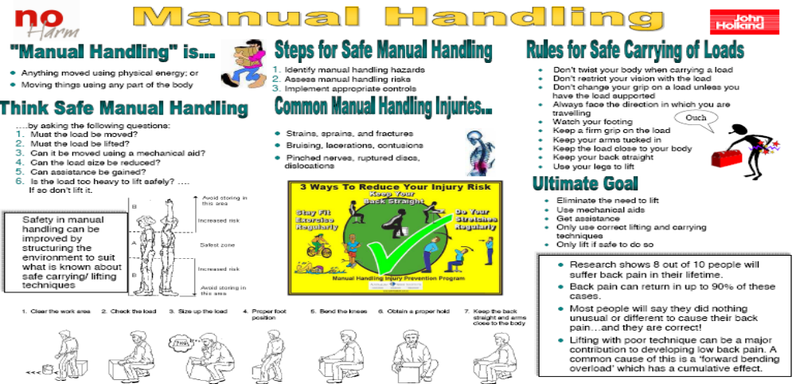

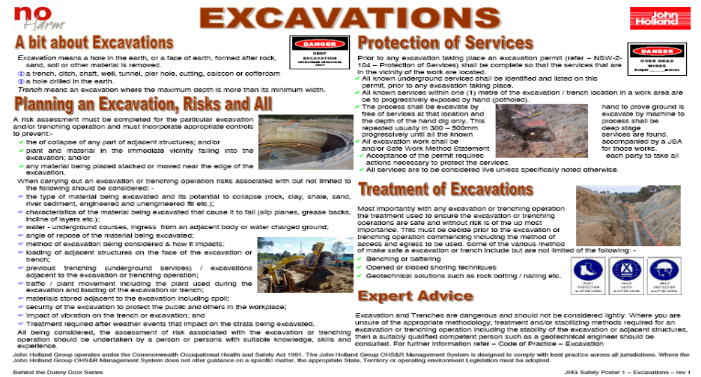

Name and Qualifications of person Supervising the Work: Mr. Mick Campton – Senior Supervisor

RISI INDUCTION, WorkCover construction induction to the construction industry, Mr Mick Campton minimum of 30 years construction.

Duties:

Supervise the work carried out as specified. Mick Campton will inspect all works at completion with client rep before leaving site for satisfaction, ensure all new people to this facility are inducted to the safety requirements, all personnel are suitably competent and have qualification for appropriate tasks, approve work methods used, and confirm isolation power out and other isolation requirements. Mr Mick Campton will go through this SWMS with all persons on the job before starting so all are aware of all safety requirements and controls put in place.
Legislation and Codes of Practice  NSW Occupational Health and safety act 2000  NSW Occupational Health and safety regulation 2001  WorkCover Code of Practice for Electrical Practices for Construction  WorkCover Code of Practice for noise management and protection of hearing at work.  WorkCover Code of Practice for Excavations  WorkCover Code of Practice Moving Plant  Australian Standard 4678 Earth Retaining Structures  WorkCover code of practice – Work near underground assets  Rail safety Act 2008, Testing Regulations 2008  Clean Air Act 1961  Clean Water Act 1970  Noise control Act 1975  Rail Safe Network Rules  Rail Safe Network Procedures | QA Procedures  Work Near and around Mobile plant  Plant and Equipment safety  Hazard reporting  Managing safety risk  Material handling  Drugs and Alcohol  Isolation systems  Personal Protective Equipment  Electrical equipment testing  (Included as attachments)  ARTC Engineering Standards  John Holland Worksite Method Plan  John Holland Related Principle
Client Approval:
Client has read and accepts the work method and controls established in order to complete the project as requested.

Client Representative: Position: Date Approved:

Safe Work Method Statement - Skills Matching + Consultation & Review Sign Off
Date of Analysis: 24.03.10 |  |  | SWMS Identifier: Rod Rowlands |  |  |  |  | Supervisor: Mick Campton
Analysis of Training / Skills or Competencies Required
Training / Skill / Competency Required to Complete the Work Safely |  |  |  |  |  |  | Construction Industry Safety Induction | Project Specific Induction |  | RISI Ticket | Senior First Aid |  | Railway Protection |  | Elevated Work Platform |  | Dogman |  | Excavator Operator |  | Traffic Control
A = All employees are required to hold. |  |  |  | Percentage of personnel required to hold (%) |  |  | A | A
 |  |  |  | Number of personnel required to hold |  |  | A
Name | Position |  |  | Signature |  | Date | Training / Skill / Competency held by employee – tick (✓) – evidence must be available
Sandra Veli | Project Safety Coordinator
Wally Elford | Supervisor
Rod Rowlands | Senior Signalling Engineer
Identified Training Needs
Training identified |  | Person Requiring Training |  |  | Date required | Training provider |  | Interim Measure in place |  |  |  |  |  |  |  |  |  |  |  |  |  | Date Complete

By signing this form, you are certifying that you have read, understood the SWMS and will comply with the safety standards related to the task(s) you are performing on the worksite.

Please note that at the time of preparation of Safe Work Method Statement, all persons requiring undertaking the works have not been identified.

Print Name | Signature | Company | Date

Print Name | Signature | Company | Date

